**Most important analytical tools and metrics used in**

**marketing analytics**

Marketing analytics refers to the practice of measuring, managing, and analyzing marketing data to gain insights and make informed decisions to optimize marketing strategies and campaigns. It involves collecting and analyzing data from various marketing channels and tactics to evaluate their effectiveness and return on investment (ROI). Marketing analytics leverages data analysis techniques, statistical models, and predictive analytics to uncover patterns, trends, and correlations in marketing data.

Some key components and techniques commonly used in marketing analytics:

* Data Collection: Gathering relevant data from various sources such as websites, social media platforms, customer relationship management (CRM) systems, email marketing tools, advertising platforms, and more.
* Data Integration: Consolidating data from different sources into a central database or data warehouse to create a comprehensive view of marketing performance.
* Key Performance Indicators (KPIs): Defining and tracking KPIs specific to marketing objectives, such as customer acquisition, conversion rates, customer lifetime value (CLV), customer retention, ROI, and others.
* Descriptive Analytics: Examining historical data to understand past marketing performance and identify trends, patterns, and anomalies. Techniques like data visualization, dashboards, and reporting help in presenting the data in a meaningful way.
* Predictive Analytics: Using statistical models and algorithms to forecast future marketing outcomes, such as sales, customer behavior, market trends, and campaign performance. Predictive analytics can help optimize marketing campaigns and allocate resources effectively.
* Segmentation and Targeting: Grouping customers based on similar characteristics or behaviors to create targeted marketing campaigns. Segmentation can be based on demographic, geographic, psychographic, or behavioral factors.
* A/B Testing: Conducting controlled experiments to compare the performance of different marketing variables, such as ad copy, visuals, landing pages, pricing strategies, and more. A/B testing helps in optimizing marketing campaigns and improving conversion rates.
* Marketing Mix Modeling: Evaluating the effectiveness and ROI of different marketing channels and tactics to determine the optimal allocation of marketing budgets across various channels.
* Data Visualization and Reporting: Presenting marketing analytics insights in a visually appealing and easy-to-understand format using charts, graphs, and reports. Data visualization tools help communicate complex information effectively.

It plays a crucial role in improving marketing performance and maximizing the return on marketing investments.

why need for marketing analytics :

Marketing analytics is essential for several reasons:

* Performance Measurement: Marketing analytics allows businesses to measure and assess the performance of their marketing initiatives accurately. By analyzing data and key metrics, companies can evaluate the success of their campaigns, identify areas for improvement, and make data-driven decisions to optimize marketing strategies.
* Customer Insights: Marketing analytics helps businesses gain a deeper understanding of their customers. By analyzing customer data, behavior, and preferences, companies can segment their audience, identify target segments, and personalize marketing messages and offers. This improves customer engagement, loyalty, and retention.
* Resource Allocation: Effective marketing analytics enables businesses to allocate their resources, such as budget, time, and manpower, more efficiently. By analyzing the ROI of different marketing channels and tactics, companies can identify high-performing channels and invest resources where they are most likely to yield the best results.
* Campaign Optimization: Marketing analytics provides insights into campaign performance in real-time or near real-time. This allows marketers to identify underperforming campaigns or tactics quickly and make adjustments to optimize their strategies. A/B testing and predictive analytics help refine marketing campaigns and improve conversion rates.
* Return on Investment (ROI) Measurement: Marketing analytics allows companies to measure the ROI of their marketing activities accurately. By tracking and analyzing the financial impact of marketing campaigns, businesses can evaluate the effectiveness of their marketing spend and make informed decisions about future investments.

Marketing analytics tool :

A marketing analytics tool is a software or platform designed to help businesses collect, analyze, and interpret marketing data for the purpose of gaining insights, optimizing strategies, and measuring marketing performance.

who uses the marketing analytics tool :

Marketing analytics tools are used by various stakeholders involved in marketing and decision-making processes. Here are some key users of marketing analytics tools:

* Marketing Managers: Marketing managers are responsible for developing and implementing marketing strategies. They use marketing analytics tools to measure and evaluate the performance of marketing campaigns, track key metrics, and make data-driven decisions to optimize marketing strategies.
* Marketing Analysts: Marketing analysts are professionals who specialize in analyzing marketing data. They use marketing analytics tools to gather, clean, and analyze data, create reports and dashboards, and provide insights and recommendations based on data analysis.
* CMOs and Marketing Directors: Chief Marketing Officers (CMOs) and Marketing Directors are senior executives who oversee the marketing function within an organization. They use marketing analytics tools to monitor overall marketing performance, evaluate the effectiveness of marketing initiatives, and make strategic decisions based on data insights.
* Digital Marketers: Digital marketers leverage marketing analytics tools to track and analyze data from various digital marketing channels, such as websites, social media platforms, email marketing, paid advertising, and more. They use these tools to measure campaign performance, optimize digital marketing efforts, and improve customer engagement and conversions.
* Market Researchers: Market researchers utilize marketing analytics tools to gather and analyze market data, consumer behavior, and industry trends. They use these insights to identify market opportunities, evaluate customer preferences, and support strategic decision-making.
* Data Analysts and Data Scientists: Data analysts and data scientists are involved in the collection, integration, and analysis of marketing data. They use marketing analytics tools and advanced analytical techniques to extract valuable insights from data and build predictive models for marketing optimization.

It's worth noting that the specific users of marketing analytics tools may vary depending on the size and structure of the organization. Larger enterprises might have dedicated teams or departments focused on marketing analytics, while in smaller organizations, individuals or smaller teams may handle marketing analytics tasks.

Marketing analytics tools:

There are several types of marketing analytics tools available in the market, each specializing in different areas of marketing analysis. Here are some 3 important types of marketing analytics tools:

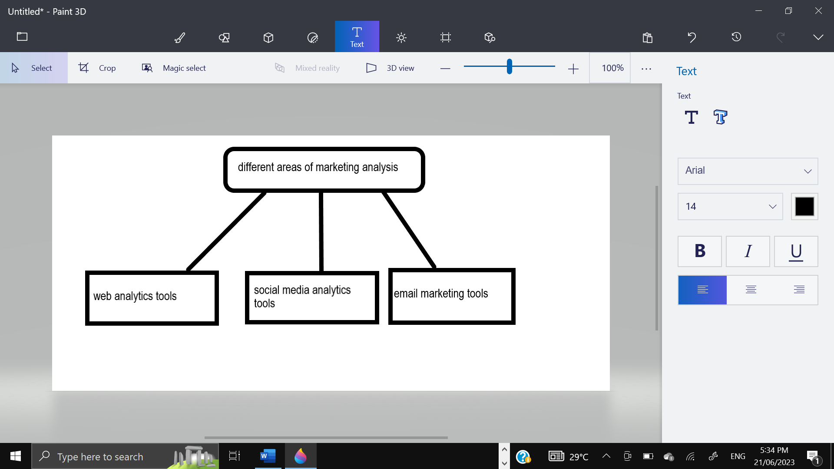

* Web Analytics Tools: Web analytics tools focus on analyzing website traffic, user behavior, and conversions. They provide insights into metrics such as page views, bounce rates, conversion rates, and user demographics.

Examples include Google Analytics, Adobe Analytics, and Matomo.

* Social Media Analytics Tools: Social media analytics tools are designed to analyze data from various social media platforms. They track engagement, follower growth, sentiment analysis, reach, and other social media metrics.

Examples include Sprout Social, Hootsuite, and Brandwatch.

* Email Marketing Analytics Tools: Email marketing analytics tools focus on analyzing the performance of email campaigns. They track metrics such as open rates, click-through rates, conversion rates, and subscriber behavior.

Examples include Mailchimp, Campaign Monitor, and Constant Contact.

Other marketing tools are:

* SEO Analytics Tools: SEO analytics tools focus on analyzing search engine optimization efforts. They provide insights into keyword rankings, organic traffic, backlinks, and competitor analysis.

Examples include SEMrush, Moz, and Ahrefs.

* CRM Analytics Tools: Customer Relationship Management (CRM) analytics tools analyze customer data and provide insights into customer behavior, segmentation, and customer lifecycle management.

Examples include Salesforce Analytics, Microsoft Dynamics 365, and Zoho CRM Analytics.

* Advertising Analytics Tools: Advertising analytics tools specialize in analyzing data from advertising campaigns, including pay-per-click (PPC) advertising, display ads, and social media ads. They track ad performance, conversions, ROI, and audience targeting.

Examples include Google Ads, Facebook Ads Manager, and AdRoll.

* Data Visualization Tools: Data visualization tools help marketers create visually appealing and interactive dashboards, charts, and reports to present marketing data in a meaningful way.

Examples include Tableau, Power BI, and Google Data Studio.

* Market Research Tools: Market research tools help businesses gather and analyze data about market trends, consumer behavior, and competitor analysis. They provide insights for strategic decision-making and market positioning.

Examples include SurveyMonkey, Qualtrics, and Nielsen.